Docker Compose and WordPress

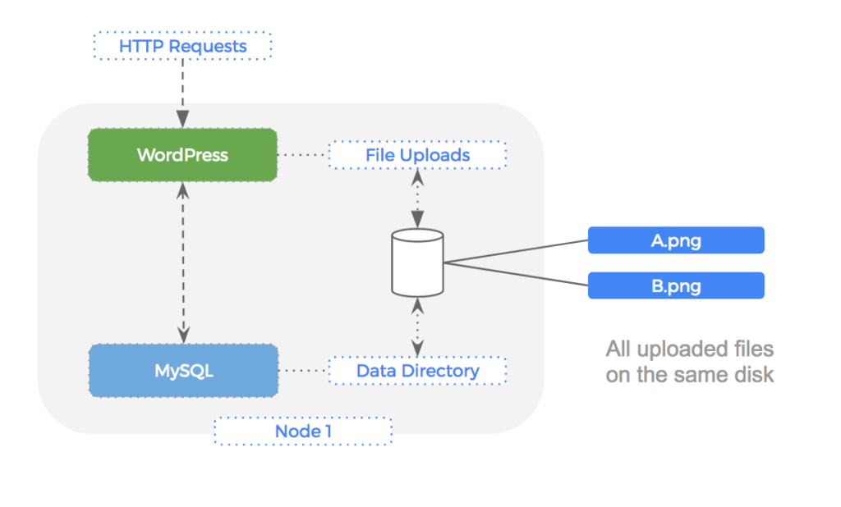

You can use Docker Compose to easily run WordPress in an isolated environment built with Docker containers.

**Install Docker Compose**

You can run Compose on macOS, Windows, and 64-bit Linux.

On Linux, you can download the Docker Compose binary from the Compose repository release page on GitHub. Follow the instructions from the link, which involve running the curl command in your terminal to download the binaries. These step-by-step instructions are also included below.

**Run this command to download the current stable release of Docker Compose:**

**sudo curl -L "https://github.com/docker/compose/releases/download/1.28.5/docker-compose-$(uname -s)-$(uname -m)" -o /usr/local/bin/docker-compose**

**Apply executable permissions to the binary:**

sudo chmod +x /usr/local/bin/docker-compose

Note: If the command docker-compose fails after installation, check your path. You can also create a symbolic link to /usr/bin or any other directory in your path.

**For example:**

sudo ln -s /usr/local/bin/docker-compose /usr/bin/docker-compose

**Test the installation.**

$ docker-compose --version

docker-compose version 1.25.3, build 1110ad01

**Creating Wordpress:**

**Create an empty project directory.**

**mkdir wordpress**

**Change into your project directory.**

cd wordpress

**Create a docker-compose.yml file that starts your WordPress blog and a separate MySQL instance with a volume mount for data persistence:**

vim docker-compose.yml

version: “3.9”

services:

db:

image: mysql:5.7

volumes:

- db_data:/var/lib/mysql

restart: always

environment:

MYSQL_ROOT_PASSWORD: somewordpress

MYSQL_DATABASE: wordpress

MYSQL_USER: wordpress

MYSQL_PASSWORD: wordpress

wordpress:

depends_on:

- db

image: wordpress:latest

ports:

- "8000:80"

restart: always

environment:

WORDPRESS_DB_HOST: db:3306

WORDPRESS_DB_USER: wordpress

WORDPRESS_DB_PASSWORD: wordpress

WORDPRESS_DB_NAME: wordpress

volumes:

db_data: {}

**Build the project:**

docker-compose up -d

Creating network "my_wordpress_default" with the default driver

Pulling db (mysql:5.7)...

5.7: Pulling from library/mysql

efd26ecc9548: Pull complete

a3ed95caeb02: Pull complete

...

Digest: sha256:34a0aca88e85f2efa5edff1cea77cf5d3147ad93545dbec99cfe705b03c520de

Status: Downloaded newer image for mysql:5.7

Pulling wordpress (wordpress:latest)...

latest: Pulling from library/wordpress

efd26ecc9548: Already exists

a3ed95caeb02: Pull complete

589a9d9a7c64: Pull complete

...

Digest: sha256:ed28506ae44d5def89075fd5c01456610cd6c64006addfe5210b8c675881aff6

Status: Downloaded newer image for wordpress:latest

Creating my_wordpress_db_1

Creating my_wordpress_wordpress_1

**Bring up WordPress in a web browser**

http://publicip:8000 external browser

**Shutdown and cleanup**

The command docker-compose down removes the containers and default network, but preserves your WordPress database.

The command docker-compose down --volumes removes the containers, default network, and the WordPress database.